The Aegina Clean Beach Initiative is a community driven project where the citizens of Aegina can come together to help protect the local beaches and further support the surrounding marine ecosystems.

Goals:
- Reduce accumulation of debris on beaches
- Promote environmental education in local schools
- Engage the community to improve the tourist perception of Aegina beaches
- Protect local ecology
Why Now?
Aegina is known for having beautiful beaches that attract tourists from around the world. A problem rising in recent years however is the accumulation of debris, specifically plastics.
How Have Other Communities Solved This Problem?
I Love A Clean San Diego
- Most popular volunteer program in California
- Over 10,000 volunteers/year
Ocean Conservancy
- Removed 144,606,491 pounds of trash from beaches over 25 years
Clean Up Sydney Harbor Day
- Over 40,000 volunteers
- Removed rusted car parts, glass bottles, and a multitude of plastics
See www.druryaegina14.weebly.com for links
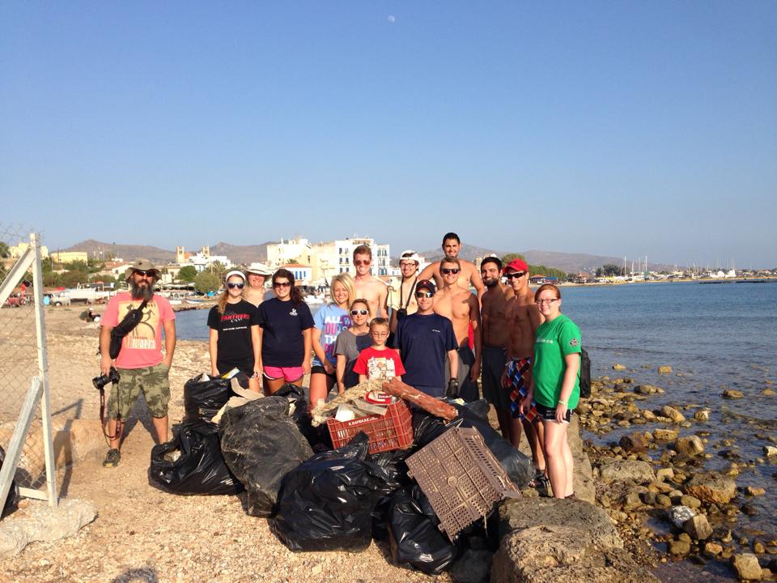

What Can You Do?
- Contact the Drury Center
- Select a beach to support
- Establish a cleaning team
- Visit your beach at least once a month for clean up
- Take photos of the progress and send them to the Drury Center in Greece Facebook
- Dispose of the collected trash in a proper way
- Donate to the Aegina Clean Beach supporters
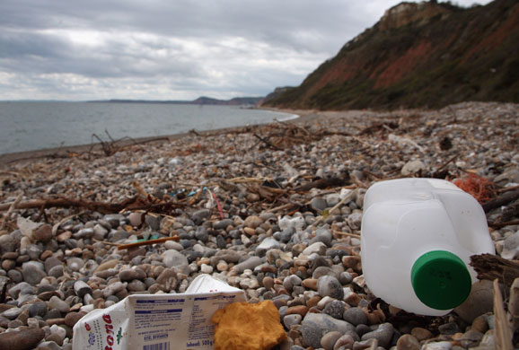

The Benefits Of Cleaning Beaches
- Reduces sea pollution by better managing debris disposal
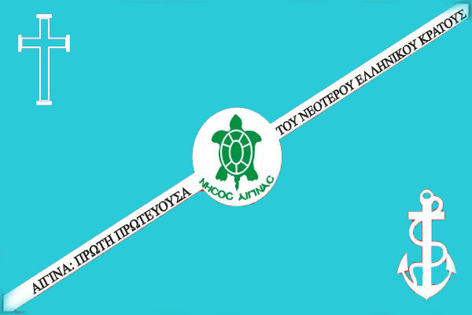
- Increases tourist attraction and interest in Aegina
- Makes a difference for the local environment by improving the water quality for marine ecosystems
- Promotes civic engagement
- Shares the knowledge about how to make a difference for future generations
What Can The Community Do To Keep Beaches Clean?
- Place trash into the correct containers
- Properly dispose of recyclables
- Encourage less use of plastic by the local businesses
- Pick up trash along the coastline
- Contact beach cleanup teams to tackle big projects
- Visit our website at www.druryaegina14.weebly.com in order to see more positive effects of beach cleaning
Drury Design: Aegina Clean Beach Flag

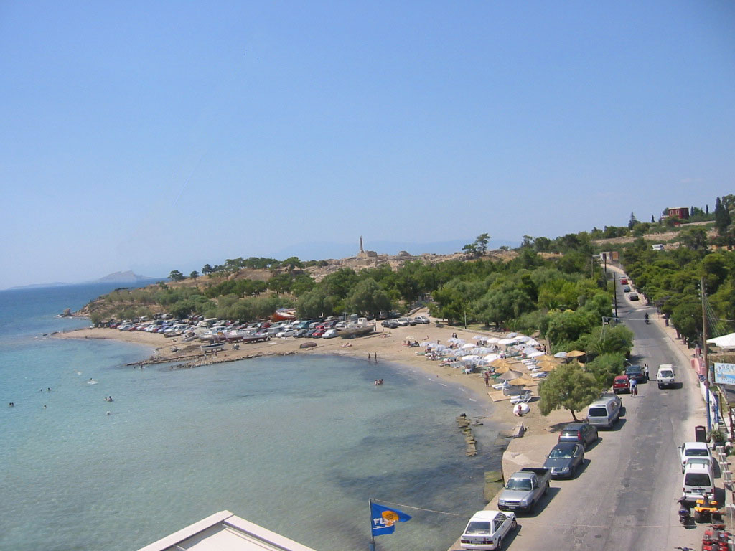
Aegina Clean Beaches Initiative
Aegina, Greece
______________________________________
Supported By:

